Table of Contents

|  |  |
| --- | --- |
| TOPIC | PAGES |
| Abstract | 2 |
| Introduction | 3-4 |
| Objectives | 5 |
| Circuit Diagram | 5 |
| Flow Chart | 6 |
| Application of the Design | 7 |
| Shortcomings/Drawbacks of the Design | 8 |
| Conclusion | 9 |
| References | 9 |
| Code | 10-12 |

**Abstract:**

The project is designed to develop distance measurement system using ultrasonic waves and interfaced with arduino. We know that human audible range is 20hz to 20khz. We can utilize these frequency range waves through ultrasonic sensor HC-SR04.The advantages of this sensor when interfaced with arduino which is a control and sensing system, a pro per distance measurement can be made with new techniques. As large amounts are spent for hundreds of inflexible circuit boards, the arduino will allow business to bring many more unique devices. This distance measurement system can be widely used as social distance meters, range meters and as proximity detectors in industries. The hardware part of ultrasonic sensor is interfaced with arduino. This method of measurement is efficient way to measure small distances precisely. The distance of an obstacle from the sensor is measured through ultrasonic sensor. After knowing the speed of sound the distance can be calculated.

**Introduction:**

Today’s the developing world shows various adventures in every field. In each field the small requirements are very essential to develop big calculations. By using different sources we can modify it as our requirements and implement in various field. In earlier days the measurements generally occur through measuring devices. But now a day’s digitalization is on height. Therefore we use a proper display unit for measurement of distance. We can use sources such as sound waves which are known as ultrasonic waves using ultrasonic sensors and convert this sound wave for the measurement of various units such as distance, speed. This technique of distance measurement using ultrasonic in air includes continuous pulse echo method, a burst of pulse is sent for transmission medium and is reflected by an object kept at specific distance. The time taken for the sound wave to propagate from transmitter to receiver is proportional to the distance of the object. In this distance measurement system we had ultrasonic sensor HC-SR04 interfaced with arduino UNO R3. Programming and hardware part of ultrasonic sensor interfacing with arduino UNO R3.

|  |  |
| --- | --- |
| 8-arduino-uno-r3-robotics-bangladesh | The Arduino UNO R3 with Cable is a micro-controller board based on the ATmega328. It has 14 digital input/output pins (of which 6 can be used as PWM outputs); 6 analog inputs, a 16 MHz ceramic resonator, a USB connection, a power jack, an ICSP header, and a reset button.  It contains everything needed to support the micro-controller; simply connect it to a computer with a USB cable or power it with an AC-to-DC adapter or battery to get started. |

|  |  |
| --- | --- |
| ultrasonic-sonar-sensor-hc-sr04-robotics-bangladesh | The HC-SR04 Ultrasonic Distance Sensor is a sensor used for detecting the distance to an object using sonar.It works by sending sound waves from the transmitter, which then bounce off of an object and then return to the receiver. |
| 16x2-lcd-blue-backlight-800x800-1 | An LCD is an electronic display module that uses liquid crystal to produce a visible image. The 16×2 LCD display is a very basic module commonly used in DIYs and circuits. The 16×2 translates o a display 16 characters per line in 2 such lines. In this LCD each character is displayed in a 5×7 pixel matrix. |
| 51ldv58kN3L._SL1100_ | LED lights are ideal for color displays, indicators, diagnostic or analytical equipment and etc. |

**Objective:**

Measuring the distance of the target objects by sending a pulsed ultrasound wave at the object and then measuring the time for the sound echo to return. Knowing the speed of the sound, the sensor can determine the distance of the object.

**Circuit Diagram:**

**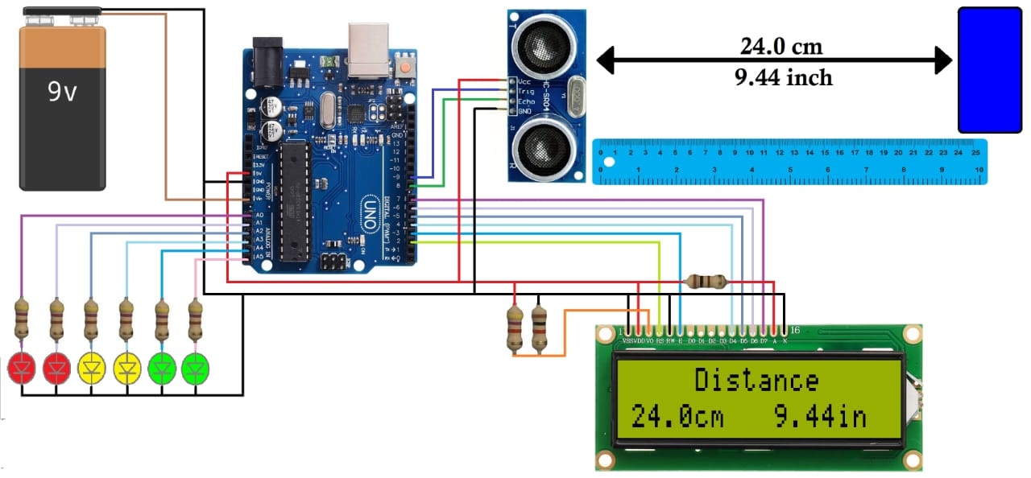**

**Flow Chart:**

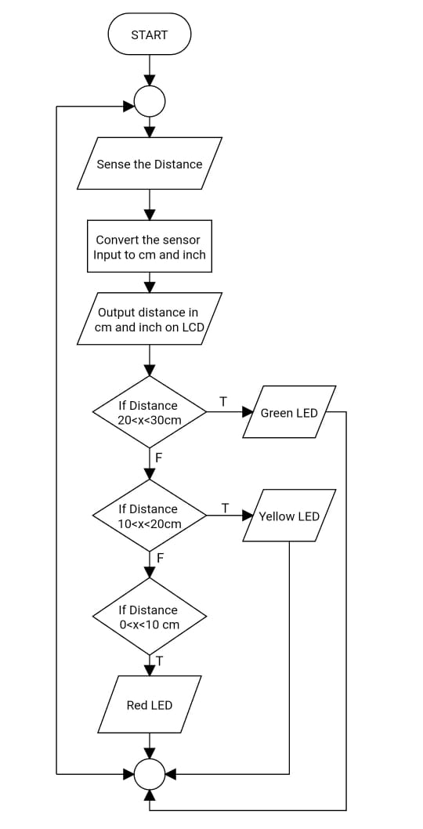

**Application of the Design:**

An ultrasonic sensor is an electronic device that measures the distance of a target object by emitting ultrasonic sound waves, and converts the reflected sound into an electrical signal. Ultrasonic waves travel faster than the speed of audible sound (i.e. the sound that humans can hear). Ultrasonic sensors have two main components: the transmitter (which emits the sound using piezoelectric crystals) and the receiver (which encounters the sound after it has travelled to and from the target). In order to calculate the distance between the sensor and the object, the sensor measures the time it takes between the emissions of the sound by the transmitter to its contact with the receiver. The formula for this calculation is,

D = ½ T x C

(where D is the distance, T is the time, and C is the speed of sound ~ 343 meters/second).

For example, if a scientist set up an ultrasonic sensor aimed at a box and it took 0.025 seconds for the sound to bounce back, the distance between the ultrasonic sensor and the box would be,

D = 0.5 x 0.025 x 343 or about 4.2875 meters

Ultrasonic sensors are used primarily as proximity sensors. They can be found in automobile self-parking technology and anti-collision safety systems. Ultrasonic sensors are also used in robotic obstacle detection systems, as well as manufacturing technology.

**Shortcomings/Drawbacks of the Design:**

#### ****Have a limited detection range****

Ultrasonic sensors detects objects from 2cm to almost 2.15 metes. Longest range sensors have a maximum range of 10 meters, cargo sensor detects up to 16.5m. This is a disadvantage in certain applications.

#### ****Cannot work in a vacuum****

Because ultrasonic sensors operate using sound, they are completely nonfunctional in a vacuum as there is no air for the sound to travel through.

#### ****Not designed for underwater use****

**Ultrasonic sensors can be completely nonfunctional in underwater measurements as it was not built for such situations.**

#### ****Sensing accuracy affected by soft materials****

Objects covered in a very soft fabric absorb more sound waves making it hard for the sensor to see the target.

**Conclusion:**

In this work, a distance measurement meter is designed by simulation software, and an experimental setup is implemented to validate the work. A low-cost ultrasound sensor is used in this work to minimize the device cost. The sensor is adapted with environmental conditions very easily. Hence it is enhanced the performance of the pulse-echo measuring system. However, the amplitude of the echo depends on the reflecting material types, shape, size, and distance. This meter is able to measure the distance between 2cm to 2.15m. Therefore, the proposed devise is very much suitable to measure the distance between the obstacle in the road and vahical body to provide safety with low cost.

**References:**

1. Ultrasonic Distance Sensor (HC-SR04):

<http://wiki.sunfounder.cc/index.php?title=Ultrasonic_Module>

1. 16\*2 LCD Display:

<https://www.electronicsforu.com/technology-trends/learn-electronics/16x2-lcd-pinout-diagram>

1. Arduino UNO R3:

<https://www.pololu.com/product/2191#:~:text=The%20Arduino%20Uno%20R3%20is,to%2Duse%20Arduino%20computer%20program.>

1. How does sensor work with Arduino:

<https://www.youtube.com/watch?v=WusuCbBA5wM>

**CODE:**

#include <LiquidCrystal.h>

LiquidCrystal lcd(2, 3, 4, 5, 6, 7);

#define echoPin 8 //echo pin

#define trigPin 9 //Trigger pin

#define led1 A0 //red led 1

#define led2 A1 //red led 2

#define led3 A2 //yellow led 3

#define led4 A3 //yellow led 4

#define led5 A4 //green led 5

#define led6 A5 //green led 6

float time;

float distance\_cm;

float distance\_in;

void setup(){

// put your setup code here, to run once:

Serial.begin(9600);

pinMode(trigPin, OUTPUT);

pinMode(echoPin, INPUT);

pinMode(led1, OUTPUT);

pinMode(led2, OUTPUT);

pinMode(led3, OUTPUT);

pinMode(led4, OUTPUT);

pinMode(led5, OUTPUT);

pinMode(led6, OUTPUT);

lcd.begin(16, 2);

lcd.setCursor(0,0);

lcd.print(" Welcome!");

lcd.setCursor(0,1);

lcd.print("EECE PROJECT");

delay(4000);

lcd.clear();

}

void loop(){

digitalWrite(trigPin, LOW); //PULSE \_\_\_|---|\_\_\_

delayMicroseconds(2);

digitalWrite(trigPin, HIGH);

delayMicroseconds(10);

time = pulseIn(echoPin, HIGH);

distance\_cm = (time/2) / 29.1; // distance for centimeter

distance\_in = (time/2) / 73.914; // distance for inch

lcd.setCursor(0, 0);

lcd.print(" Distance ");

lcd.setCursor(0, 1);

lcd.print(distance\_cm,1);

lcd.print("cm ");

lcd.setCursor(9, 1);

lcd.print(distance\_in);

lcd.print("in ");

Serial.print("cm= ");

Serial.print(distance\_cm);

Serial.print(" inch= ");

Serial.println(distance\_in);

if(distance\_cm<30){digitalWrite(led6, HIGH);}

else{digitalWrite(led6, LOW);}

if(distance\_cm<25){digitalWrite(led5, HIGH);}

else{digitalWrite(led5, LOW);}

if(distance\_cm<20){digitalWrite(led4, HIGH);}

else{digitalWrite(led4, LOW);}

if(distance\_cm<15){digitalWrite(led3, HIGH);}

else{digitalWrite(led3, LOW);}

if(distance\_cm<10){digitalWrite(led2, HIGH);}

else{digitalWrite(led2, LOW);}

if(distance\_cm<5){digitalWrite(led1, HIGH);}

else{digitalWrite(led1, LOW);}

delay(200);

}